# On PC where laser is connected

1. Press **Win+R**
2. Type “**cmd**”
3. Type command “**ipconfig**”
4. Find PC **IP addres** (see example below)

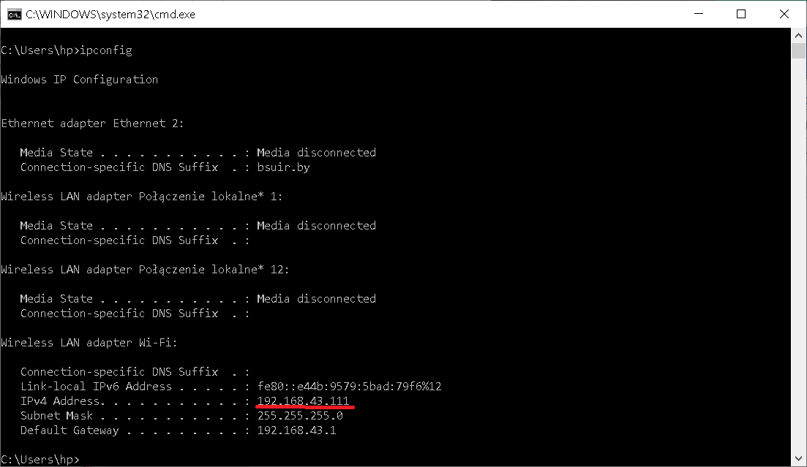

# On another PC (in same LAN)

1. Press **Win+R**
2. Type “**cmd**”
3. Type “**ping <ipaddres>**” where <ipaddres> is IP address PC where laser is connected
4. Result should be like this:

